Dominic Bumpus Network Design Final Phase 1
Overview:
Trine University needs to create a network design for the Indiana campus that includes the Engineering, Nursing, IT, Finance, Management, and Staffing departments. Requirements for the network design include the Network Diagram itself, IP address Distribution, VLAN names and related IP subnets, Network devices needed for the design along with these devices’ models and pricing, and Network server and applications required for the network design.
Network Diagram:
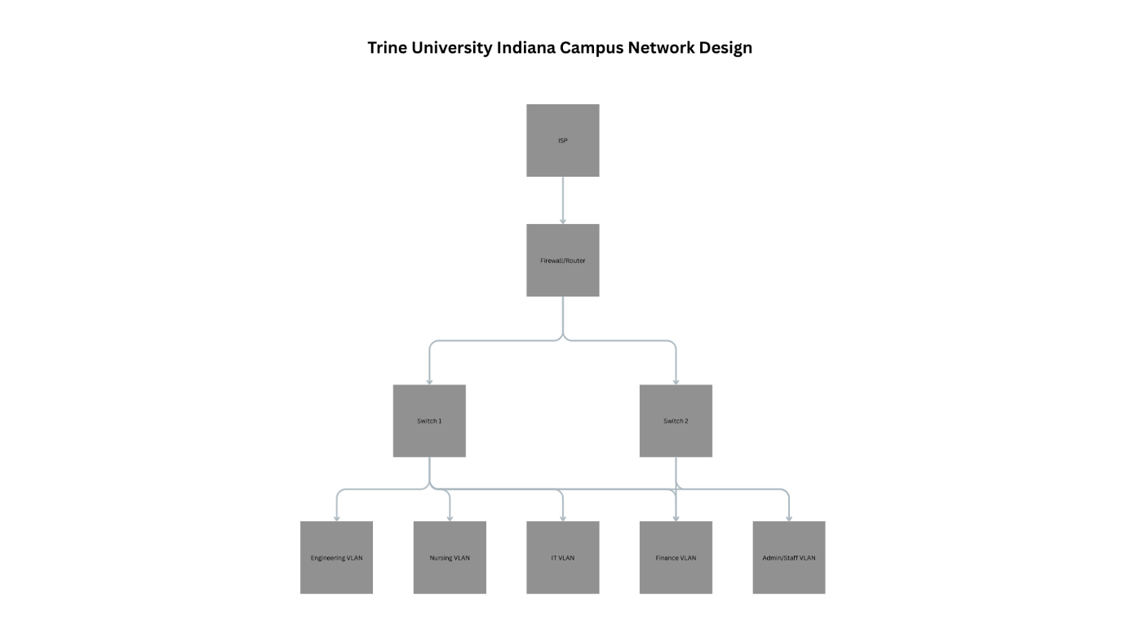
IP Address Distribution:
Department | VLAN ID | Subnet | Host Capacity
Engineering | 10 | 10.10.0/20 | 4,094
Nursing | 20 | 10.20.0/21 | 2,046
IT | 30 | 10.30.0/22 | 1,022
Finance | 40 | 10.40.0/23 | 510
Management | 50 | 10.50.0/24 | 254
Staffing/Admin | 60 | 10.60.0/24 | 254

VLAN Names and Subnet:
VLAN ID | VLAN Name | Subnet
10 | ENG_VLAN | 10.10.0/20
20 | NURSING_VLAN | 10.20.0/21
30 | IT_VLAN | 10.30.0/22
40 | FIANACE_VLAN | 10.40.0/23
50 | MGMT_VLAN | 10.50.0/24
60 | STAFF_VLAN | 10.60.0/24
Network Devices:
Device | Description | Cost
Cisco Firepower 101 | Enterprise Firewall, VPN, IPS, Routing | ~$900
FortiGate 60F | NGFW with High Throughput | ~$800
Cisco Catalyst 9500 | Backbone switch | ~$12,000
Aruba 5412R zl2 | Modular core switch | ~$9,000
Cisco 2960x | 48-Ports, PoE for phones/APs | ~$2,000
Cisco Catalyst 9120AX | Wifi6 | ~$700
Aruba AP515 | Wifi6 | ~$650
Dell PowerEdge R470 | Virtualization Server | ~$6,000
Required Servers and Applications:
The core servers will include an active directory domain controller, a DNS server, a DHCP server, a file server, a print server, a database server, an application server, an LMS server, and a network monitoring server. Security services will include RADIUS for Wi-Fi authentication, SIEM, and a backup server. These cover all the necessities for a campus network.

References:
IEEE SA. (n.d.). IEEE Standards Association. IEEE Standards Association. https://standards.ieee.org/ieee/802.1Q/6844/
GeeksforGeeks. (2025, October 3). Virtual LAN (VLAN). GeeksforGeeks. https://www.geeksforgeeks.org/computer-networks/virtual-lan-vlan/
GeeksforGeeks. (2025, October 7). What is an IP Address? GeeksforGeeks. https://www.geeksforgeeks.org/computer-science-fundamentals/what-is-an-ip-address/
VLANs and the Cisco hierarchical design model. (n.d.). https://learningnetwork.cisco.com/s/question/0D53i00000U2gJ2CAJ/vlans-and-the-cisco-hierarchical-design-model
Cisco Next Generation Firewall (NGFW) demo. (2025, September 3). [Video]. Cisco. https://www.cisco.com/site/us/en/products/security/firewalls/firepower-1000-series/index.html
FortiGate FortiWiFi 60F Series Data Sheet | Fortinet. (n.d.). Fortinet. https://www.fortinet.com/resources/data-sheets/fortigate-fortiwifi-60f-series
Cisco Catalyst Center Zero Trust Network demo. (2025, November 5). [Video]. Cisco. https://www.cisco.com/site/us/en/products/networking/switches/catalyst-9500-series-switches/index.html
Cisco Catalyst 9200 Series Switches product video. (2025, November 4). [Video]. Cisco. https://www.cisco.com/site/us/en/products/networking/switches/catalyst-9200-series-switches/index.html
HPE Store. (n.d.). HPE Aruba Networking 5400R zl2 Switch Series | HPE Store. https://buy.hpe.com/us/en/networking/switches/modular-ethernet-switches/hpe-aruba-networking-5400r-zl2-switch-series/p/7074783
Cisco Catalyst 9120AX Series Access Points Data Sheet. (2024, February 26). Cisco. https://www.cisco.com/c/en/us/products/collateral/wireless/catalyst-9120ax-series-access-points/datasheet-c78-742115.html
HPE Store. (n.d.). HPE Aruba Networking AP-515 (US) Dual Radio 4x4/2x2 802.11AX Internal Antennas Unified Campus AP | HPE Store. https://buy.hpe.com/us/en/networking/wireless-devices/wlan-access-points/hpe-aruba-networking-ap%E2%80%91515-us-dual-radio-4x4-2x2-802-11ax-internal-antennas-unified-campus-ap/p/q9h63a
Dell PowerEdge R470 Rack Server | DeLl United States. (n.d.). https://www.dell.com/en-us/shop/cty/pdp/spd/poweredge-r470/pe_r470_tm_vi_vp_sb

